John Dowland and His Melancholy Song: “Flow My Teares”

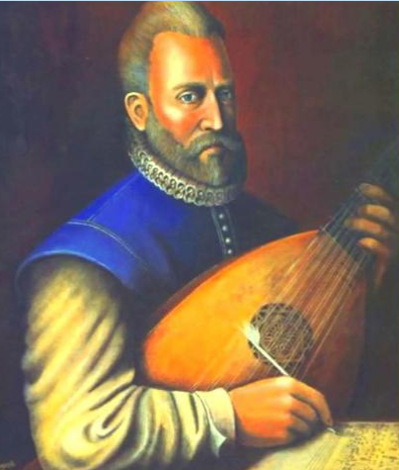

John Dowland (b. 1562/3—d. Jan 1626, his birth and death dates are debated), is primarily remembered as a melancholic musician. There are no known images attributed to his likeness. However, the above image is the one most closely associated with him. He was an English composer, virtuoso lutenist[1], and skilled singer (The Editors of *Encyclopaedia Britannica*). Dowland was also a polyglot: fluent in English, Latin, French, with some knowledge of Italian, German, and Danish languages. Fellow musician and writer Walter Bitner noted he was one of the “finest lutenists of his time (if not the finest), one of the foremost composers, and acknowledged today as the first great songwriter in the English language” (Bitner). He was eventually awarded a Bachelor of Music degree at Christ Church, Oxford, on July 8, 1588, alongside English composer Thomas Morley. In 1612, he was also appointed as one of the “musicians for the lutes” to James I (EB), a very “prolific musician” indeed (Clapp-Itnyre). Although respecting tradition, he lived during a time of “musical transition,” absorbing several new ideas. His 88 lute (or "ayre") songs, printed from 1597–1612 primarily, reflect these growing influences (EB).

“Flow My Teares,” published in 1600, was initially composed as an instrumental theme, based off his lute *Lachrimae Pavane*; published in the *Second Booke of Songs* (Childed). “Flow My Teares” remains an attractive song because of the relevant sentiments it provokes, expressing the melancholy of someone whose happiness has been ripped away; unable to be saved from misery. It is a “very sad lament,” echoing other English poems bemoaning “poor, lonely lives… a song following this sentiment” (Clapp-Itnyre 113). Its tune provokes a memorable depth of sorrow well worth noting.

Works Cited:

Bitner, Walter. “ ‘To Attain So Excellent A Science’: John Dowland, Part I.” *Walter Bitner Off the*

*Podium*. Accessed 28 Feb. 2020.

Clapp-Itnyre, Alisa. “Camelot, Past and Present. A Concert of Medieval Ballads, Ending with

Songs from the Musical, *Camelot.*” *Indiana University East Online*. Accessed 28 Feb.

2020.

Childed, Serg. “Classical Guitar.” *Music Tales*. Accessed 28 Feb. 2020.

Editors of Encyclopædia Britannica. “John Dowland: English musician.” *Encyclopædia Britannica*.

2020. Accessed 28 Feb. 2020.

Editors of Encyclopædia Britannica. “Lute. Musical instrument.” *Encyclopædia Britannica*. 2020.

Accessed 28 Feb. 2020.

“Open Music Library.” *John Dowland 1563–1626*. 2020. Accessed 28 Feb. 2020.

1. [Lute](https://www.britannica.com/art/lute): in music, any plucked or bowed chordophone whose strings are parallel to its belly, or soundboard, and run along a distinct neck or pole. A musical instrument (EB).